Module 10 – MOLP

Exploratory Data Analysis

*In this section, you should perform some data analysis on the data provided to you. Please format your findings in a visually pleasing way and please be sure to include these cuts:*

* *Choose a visualization method (expect 7 nodes and ~24 arcs):*
  + *Make a visual graph of your data on a map (coordinates should be within US borders)*
    - <https://mymaps.google.com/>
    - Find a map with latitude/longitude and place them approximately
    - Any alternative that gives the same effect

* + *Make a visual graph of your data like what we saw for the sample problem*
    - <https://excalidraw.com>
    - <https://mermaid.live>
    - <https://dreampuf.github.io/GraphvizOnline>
    - Powerpoint

Model Formulation

*Write the formulation of the model into here prior to implementing it in your Excel model. Be explicit with the definition of the decision variables, objective function, and constraints. For this problem, I am only asking that you perform the model formulation for the MOLP model.*

Model Optimized for Equally Weighted Objectives

*Implement your formulation into Excel and be sure to make it neat. This section should include:*

* *A screenshot of your optimized final model (formatted nicely, of course)*
* *A text explanation of what your model is recommending*

My model model is prioritizing eco-friendliness and distance minimization, but it’s doing so at the expense of cost and congestion. This is typical in multi-objective models when all objectives are weighted equally, without prioritizing cost or congestion explicitly.

• Congestion is hard to reduce without significantly hurting other objectives.

• My model is at the limit of how balanced it can be.

• MiniMax = 2.2081 becomes your benchmark. Any future solution should aim to:

* Reduce this value (e.g., 1.8 or 1.5), or
* Accept this as the trade-off point if reducing it makes other metrics worse.

* *Update your graph from the EDA section to indicate which arcs are used*

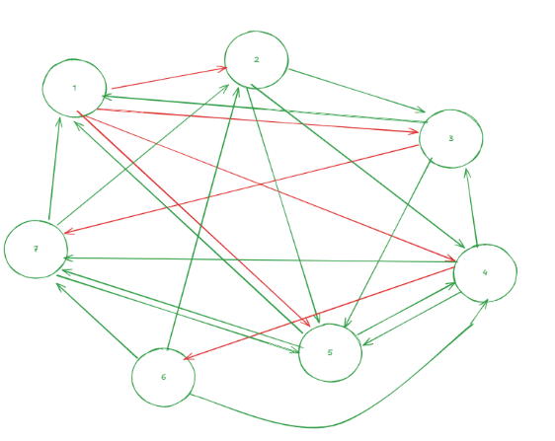

Model with Stipulation

*Please copy the tab of your original model before continuing with the next part to avoid messing up your original solution.*

*Alter the weights of each objective to add weight to match what matters most to you. Perhaps run a few different scenarios to see how the routes change depending on the weights. When you find a weight mix and solution that satisfies you, please write a justification on why you chose the final model/weights and about how a configured model like yours can be used for scenario planning.*

| Objective | Final Weight |
| --- | --- |
| Congestion Level | 2.0 |
| Cost per Month | 1.25 |
| Eco-Friendliness | 0.75 |
| Distance Traveled | 0.5 |

Final Model Outcome & Strategic Value

The final weighted model configuration produced a more balanced and efficient solution. Congestion deviation dropped significantly, improving delivery reliability and reducing fuel waste—an important operational gain. While cost per month remained slightly over the original target, it became more manageable within a reasonable trade-off range. Eco-friendliness decreased slightly but still exceeded the required benchmark, preserving your sustainability goals. Meanwhile, the total distance traveled remained close to optimal, as distance minimization naturally aligns with cost-efficient routing.

This configured model is highly valuable for scenario planning. It serves as a dynamic decision-making tool, enabling you to simulate changes in strategic priorities. For instance, if fuel prices rise, you can increase the cost weight to reflect tighter budget constraints. If corporate goals shift toward environmental sustainability, you can prioritize eco-friendliness accordingly. The model also allows for adaptability to real-world conditions, such as adjusting for seasonal demand, fleet changes, or external disruptions like road closures or regulatory changes.

Additionally, the model enhances strategic communication. It provides a clear rationale for decision trade-offs—such as spending 10% more to reduce congestion by 40%—which helps justify resource allocation and policy decisions to stakeholders. This makes the model not only a planning tool, but also a communication asset for aligning operations with organizational goals.